SQL Injection Attacks

The idea behind all forms of injection attack is to try and make our own unauthorised code run on the system under attack.

The first form of injection attack we shall look at is SQL injection.

So far with the DVD Swap Shop we have set about implementing rudimentary security measures to control access to the system.

The most common way of doing this is to include a log-in facility so that we are able to authenticate who may or may not use the system.

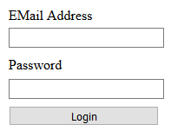

The problem is that without designing the code correctly this has the potential to open up large security vulnerability.

Let’ have a go and see what we do first.

You will need to make sure that you are using the DVD Swap program provided at the start of the module to play with this approach of getting into the system, not your own swap shop.

Take a look at the following section of text…

hi' or '1'='1

What we will do is use this text as both the username and password in the program like so…

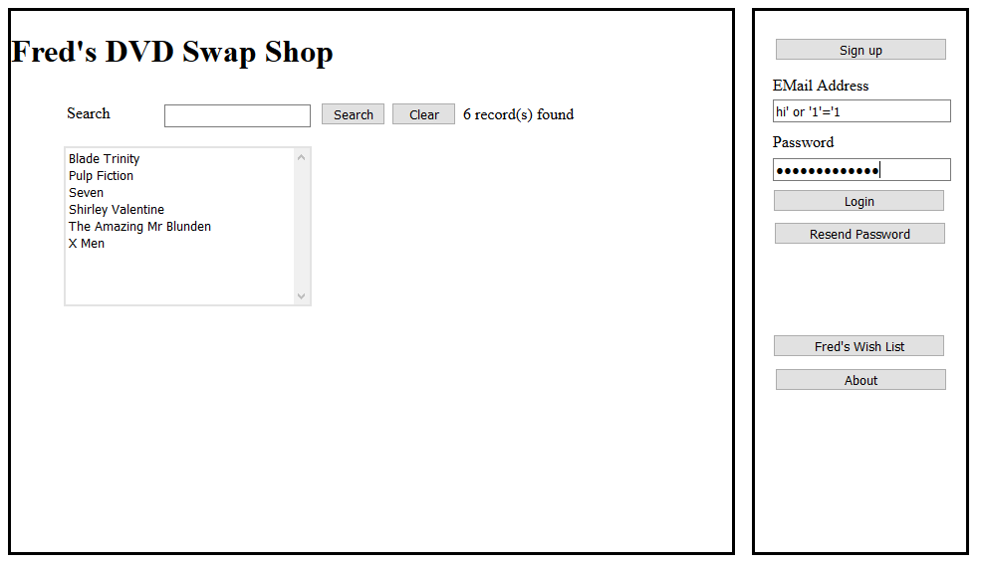

Then press Login.

What should happen is that the system should tell you that the login is unauthorised. What actually happens is that it logs you in as a valid user of the system.

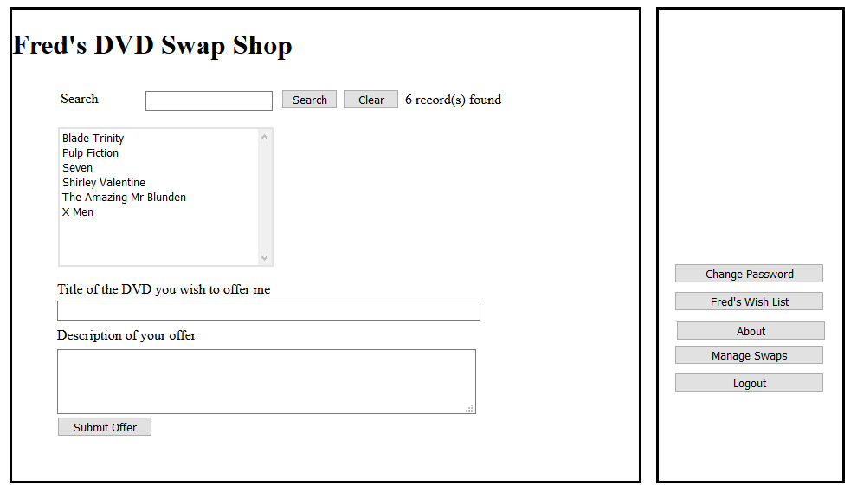

What is worse is that it hasn’t just allowed you access it has in fact logged you in as the administrator!

So what is going on?

The Problem of Concatenated SQL

As you are aware by now, SQL is a language designed for querying database and stands for Structured Query Language. It is most commonly abbreviated to the three letters SQL or Sequel (as in Sequel Server)

The section of code that is allowing this SQL injection attack to happen is below

select * from Users where EMail = '" & EMail & "' and UserPassword = '" & Password & "'"

Concatenation

Concatenation is an important concept in programming and means joining sections of text together.

For example if we log in to the system using the following user name and password...

User name mjdean@dmu.ac.uk
Password password123

The programming language replaces the key words EMail and Password with the values entered by the user at the interface.

select * from Users where EMail = 'mjdean@dmu.ac.uk' and UserPassword = 'password123'"

This SQL selects all of the users matching that email and password.

We then test the count of users found and if it greater than zero, we assume the details to be valid and allow the login.

So what happens if we enter hi' or '1'='1

In this case the SQL concatenates to the following...

select * from Users where EMail = 'hi' or '1'='1' and UserPassword = 'hi' or '1'='1'

What has happened is that the single speech mark has terminated the strings early and since 1 always equals 1 we return all of the records in the user table.

As before there are more than zero records so it logs the user in as the first record in the table.

Since the first user on any system is often the administrator we suddenly have admin rights in the application.

Using the Debugger
To see this more clearly we will track the process through using the debugger.

Again using the original copy of the DVD Swap Shop, double click the login button to view the event handler…

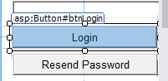

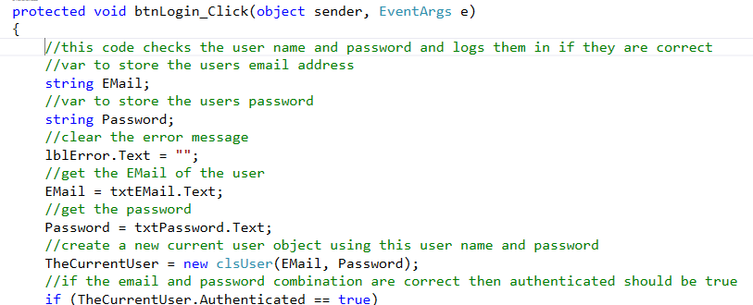

On a suitable line of code insert a break point by pressing F9…

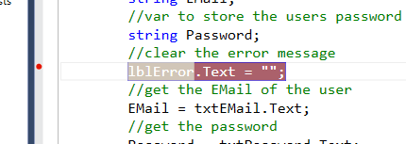

Now run the program and as before use the SQL injection code to log in to the system. This time the code will pause at the break point…

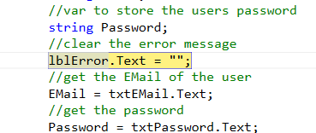

Pressing F10 twice will advance the code such that you will be able to see the text in the password and email text boxes copied to the variables.

Eventually you will reach the following line of code…

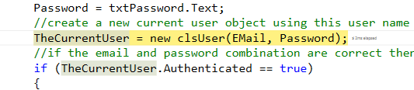
At this stage you need to press F11 to step into the constructor for the class clsUser which takes you here…

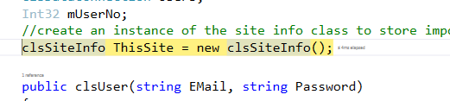

Press F10 again and the constructor will execute…

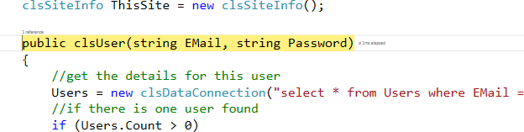

Press F10 until you get to the following line…

Note how this version of the data connection works differently to the data connection used on Visual Web Development.

As part of the class’s constructor it accepts concatenated SQL in order to access the underlying database.

Press F11 to step into the constructor for the class…

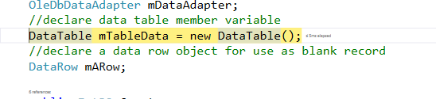

Eventually you will get to here…

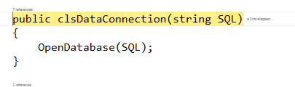
Hold the mouse over the SQL parameter and you will be able to view the final concatenated SQL which should look something like this…

"select * from Users where EMail = 'hi' or '1'='1' and UserPassword = 'hi' or '1'='1'"

As explained above 1 will always match 1 regardless of there not being a user name or password matching the word “hi”.

The result is that all of the records in the Users table are returned. As is often the case when developing a system the first record to be created is the administrator of the system. Being the first record in the table, the credentials for this user are the ones returned…

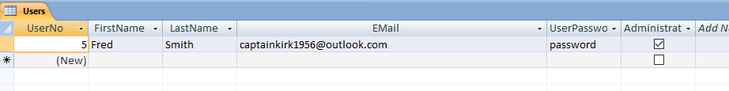

So how do we fix this?

The answer is pretty simple; when it comes to security never use concatenated SQL!

But what is the alternative?

The alternative is to use parameterised queries or stored procedures.

Parameterized Queries

With the work in other modules you will already have made use of parameters in your stored procedures without realising the importance of them.

For example the following is the SQL for your very first stored procedure in Visual Web called sproc_tblAddress_Delete…

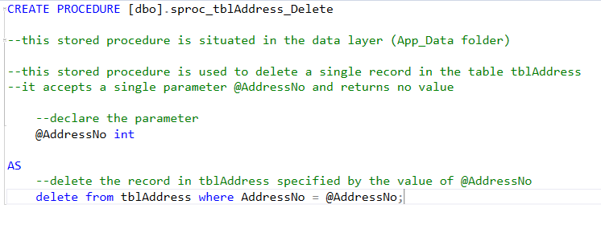
Notice the parameter @AddressNo which is used in the delete SQL at the bottom of the code. Rather than concatenating the parameter into the SQL we use it directly.

By making use of stored procedures in this way we add an extra layer of security to the system…

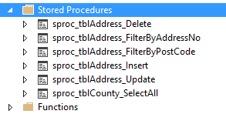

Parameterized Queries in Access

So the question then arises is it possible to do this in MS Access? The answer is a definite yes.

To complete the next section of the work you will need to use your own version of the swap shop.

The first thing to note is that your SQL injection attack won’t work on this version of the system. Try it and it should fail.

The reason for this is that we have already added a level of security by including a password hash. Rather than the SQL concatenating to…

"select * from Users where EMail = 'hi' or '1'='1' and UserPassword = 'hi' or '1'='1'"

It actually concatenates to the following…

"select * from Users where EMail='hi' or '1'='1' and UserPassword='47BD092F1FCA1FB740FC83C9F34205131EC7FCC9EE5CC9562665FE4C380BFBE3'"

Which breaks the injection attack to a certain extent, but we can do a lot better than this.

To add the query you will need to open up the database in Access and under the Create menu add a new Query Design…

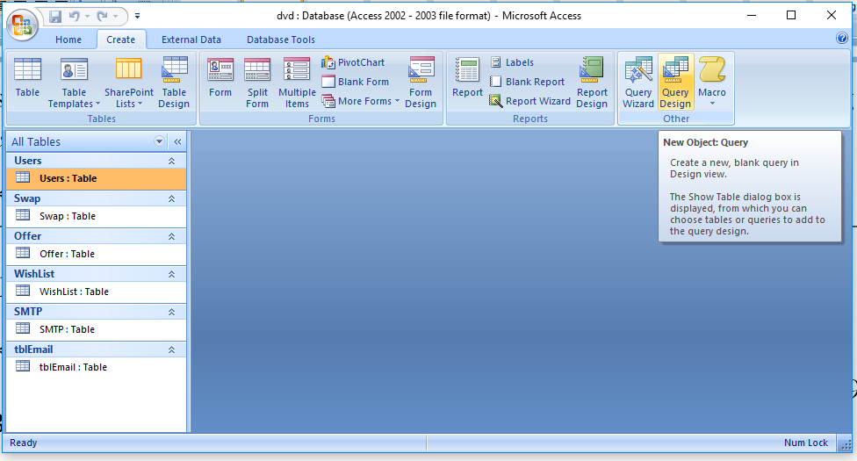

When it asks you which tables to use select the Users table and press Add…

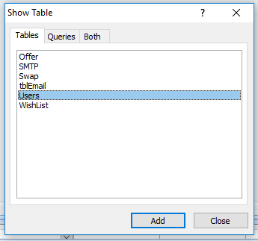
Then press close which will take you to the query designer. Access queries are not stored procedures in the true sense but we can create much of the same functionality.

Modify the query to include the fields Email and UserPassword…

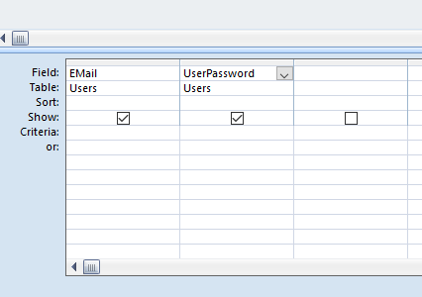

Next we can add the parameters, pretty much like we would in SQL server…

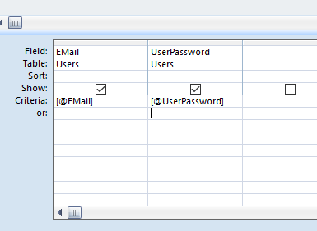

Don’t miss out the square brackets so that Access knows that these are parameters!

Next run the query 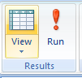 (you are best to copy and paste a hashed password for a valid user).

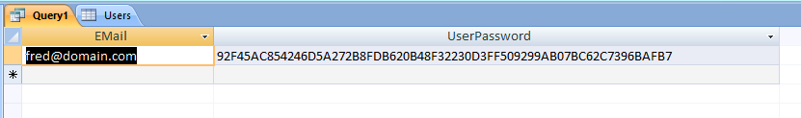

Close the query and save it as qry_Users_FilterByEmailAndPassword

Updating the Data Connection

Now that we have set up the query in the data layer we need to modify the middle layer with a data connection that doesn’t use concatenated SQL and also works with MS Access.

On the module web site is a new data connection for download called clsDataConnectionOLDB. The OLDB data provider is a system for accessing different database and works with Access.

https://msdn.microsoft.com/en-us/library/ms722784(v=vs.85).aspx

Create the new class in the middle layer and paste the code into it replacing all of the existing code.

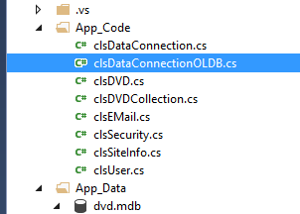

The next step is to modify the login function in clsSecurity to make use of the new class like so…

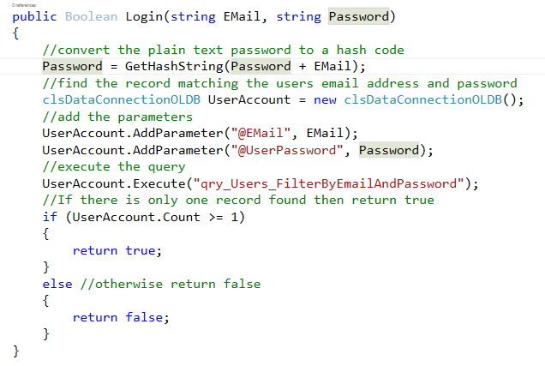
There is one important thing to notice at this stage!

In SQL server the database engine doesn’t actually care what order your add your parameters. You may do password first then email and vice versa.

Access on the other hand does care. The order you add your parameters must follow the order in which the parameters appear in your query, in this case email followed by password…

Things to try yourself

Now that we have the possibility of using parameterised queries in your application rather than concatenated SQL go through the code you have created so far and replace the old data connection code with the new class clsDataConnectionOLDB

